Національний технічний університет України

«Київський політехнічний інститут імені Ігоря Сікорського»

Факультет інформатики та обчислювальної техніки

Кафедра інформаційних систем та технологій

**Лабораторна робота №4**

з дисципліни "Основи клієнтської розробки"

Тема: "CSS. Контекстні селектори. Сусідні селектори. Дочірні селектори. Блочні елементи. Рядкові елементи. Позиціонування. Псевдокласи. Псевдоелементи"

Тематика:«Рецепти»

Виконав: Перевірила:

студент групи ІП-93 ст. вик. Кафедри ІСТ

Домінський Валентин Хмелюк Марина Сергіївна

Олексійович

Київ 2021

Завдання:

1. Застосувати контекстні, сусідні, дочірні селектори в рамках тематики

Результати:

Головна сторінка, де є:

1. Контекстні селектори ((p tt) та (p b))
2. Сусідні селектори ((i+strong) та (tt+em))
3. Дочірні селектори (dl>dd)

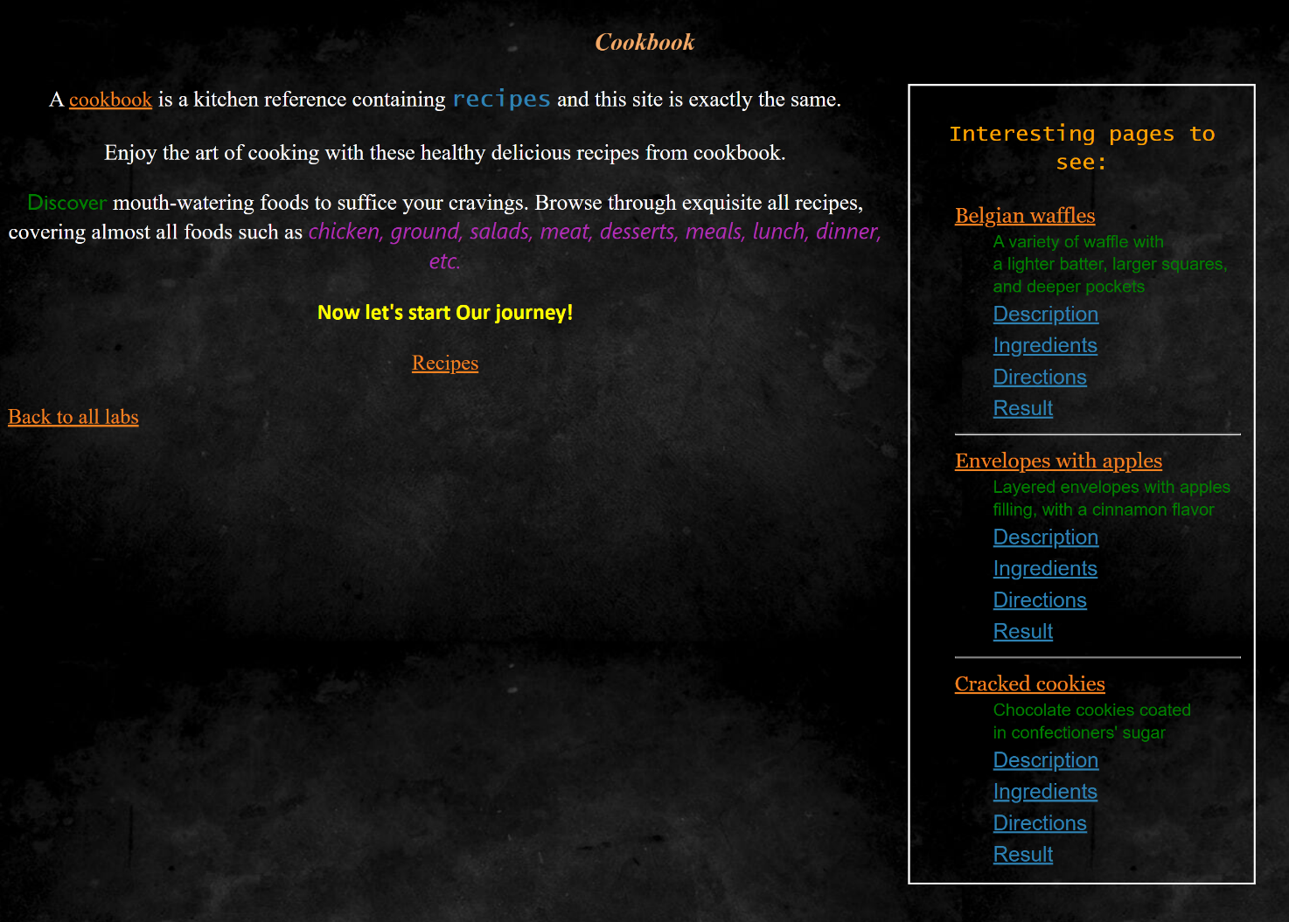

Другорядна сторінка, де є:

1. Дочірні селектори ((dl>dd) та (a>i))

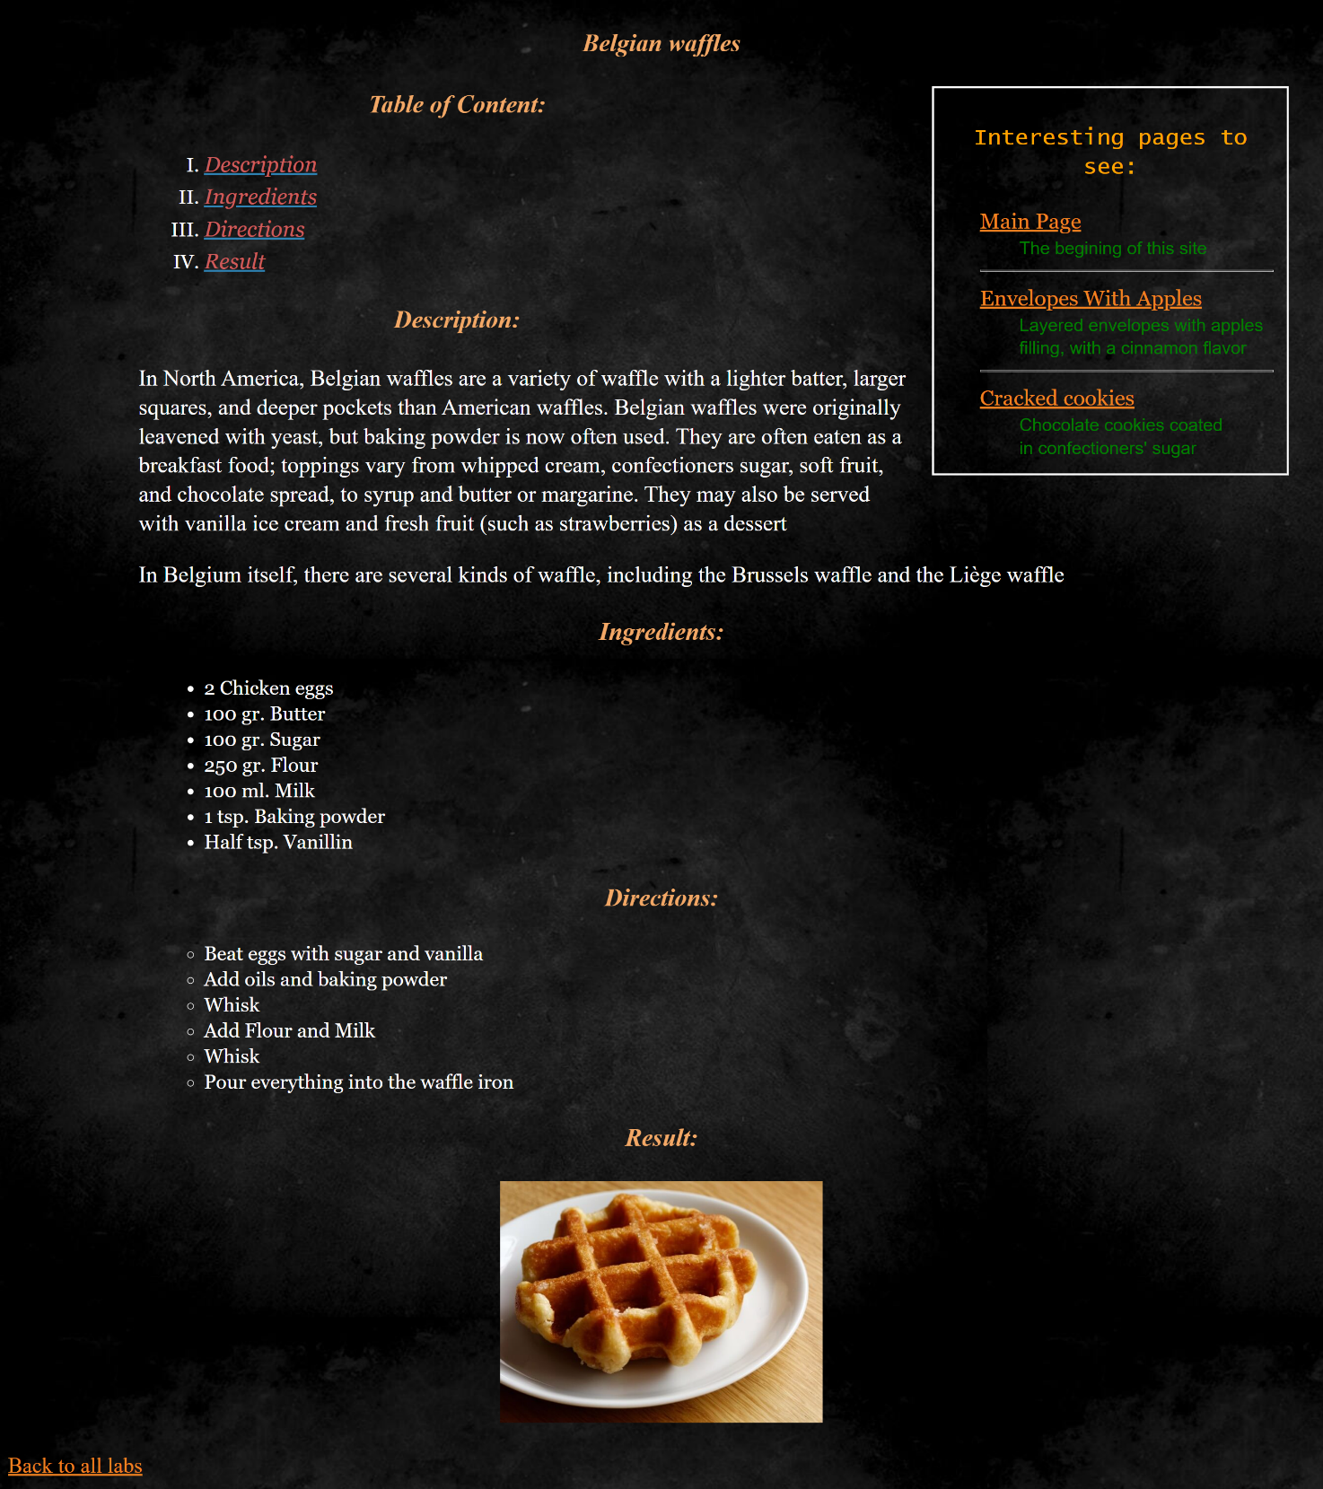

Вихідний код:

index.html:

<!DOCTYPE html>

<html lang="en">

<head>

    <meta name="author" content="Valentyn Dominskyi">

    <meta name="keywords" content="recipes, cookbook">

    <meta name="description" content="cookbook site with recipes">

    <meta charset="UTF-8">

    <meta http-equiv="X-UA-Compatible" content="IE=edge">

    <meta name="viewport" content="width=device-width, initial-scale=1.0">

    <link rel="stylesheet" href="style.css">

    <title>Main page</title>

</head>

<body>

    <header>

        <h3>Cookbook</h3>

    </header>

    <div>

        <aside>

            <p class="SidebarHeader">

                Interesting pages to see:

            </p>

            <article>

                <dl class="SidebarText">

                    <dt>

                        <a href="Belgian-Waffles.html">Belgian waffles</a>

                    </dt>

                    <dd>A variety of waffle with <br> a lighter batter, larger squares, <br> and deeper pockets</dd>

                    <dd>

                        <a href="Belgian-Waffles.html#Description">Description</a>

                    </dd>

                    <dd>

                        <a href="Belgian-Waffles.html#Ingredients">Ingredients</a>

                    </dd>

                    <dd>

                        <a href="Belgian-Waffles.html#Directions">Directions</a>

                    </dd>

                    <dd>

                        <a href="Belgian-Waffles.html#Result">Result</a>

                    </dd>

                    <hr>

                    <dt>

                        <a href="Envelopes-With-Apples.html">Envelopes with apples</a>

                    </dt>

                    <dd>Layered envelopes with apples <br> filling, with a cinnamon flavor</dd>

                    <dd>

                        <a href="Envelopes-With-Apples.html#Description">Description</a>

                    </dd>

                    <dd>

                        <a href="Envelopes-With-Apples.html#Ingredients">Ingredients</a>

                    </dd>

                    <dd>

                        <a href="Envelopes-With-Apples.html#Directions">Directions</a>

                    </dd>

                    <dd>

                        <a href="Envelopes-With-Apples.html#Result">Result</a>

                    </dd>

                    <hr>

                    <dt>

                        <a href="Cracked-Cookies.html">Cracked cookies</a>

                    </dt>

                    <dd>Chocolate cookies coated <br> in confectioners' sugar</dd>

                    <dd>

                        <a href="Cracked-Cookies.html#Description">Description</a>

                    </dd>

                    <dd>

                        <a href="Cracked-Cookies.html#Ingredients">Ingredients</a>

                    </dd>

                    <dd>

                        <a href="Cracked-Cookies.html#Directions">Directions</a>

                    </dd>

                    <dd>

                        <a href="Cracked-Cookies.html#Result">Result</a>

                    </dd>

                </dl>

            </article>

        </aside>

        <article style="text-align: center">

            <p>A <i><a href="https://en.wikipedia.org/wiki/Cookbook" target="_blank">cookbook</a></i> is a kitchen reference containing <strong>recipes</strong> and this site is exactly the same.</p>

            <p>Enjoy the art of cooking with these healthy delicious recipes from cookbook.</p>

            <p><tt>Discover</tt> mouth-watering foods to suffice your cravings. Browse through exquisite all recipes, covering almost all foods such as <em>chicken, ground, salads, meat, desserts, meals, lunch, dinner, etc.</em></p>

            <p><b>Now let's start Our journey!</b></p>

            <p>

                <a href="Recipes.html">Recipes</a>

            </p>

        </article>

    </div>

    <footer>

        <a href="../index.html">Back to all labs</a>

    </footer>

</body>

</html>

Style.css:

header {

text-align: center

}

body {

font-size: 23px;

color: #ffffff;

font-style: normal;

line-height: 1.3;

text-align: left;

background-image: url("images/Background.jpg");

}

h3 {

font-size: 25px;

color: #f3a866;

font-style: italic;

line-height: 1.5;

text-align: center;

}

aside {

float: right;

width: 25%;

height: auto;

border: 2px solid white;

padding: 1%;

margin: auto 2%;

margin-bottom: 3%;

}

p.RecipeDescription {

padding-left: 10%;

padding-right: 10%;

}

p#ParagraphWithScale {

text-align: center;

block-size: 250px;

}

p#Frame {

text-align: right !important;

margin-top: -506.5px !important;

}

#ImageWithScale {

transform: scale(0.5) translate(0%, -50%) !important;

}

p.SidebarHeader {

font-size: 5;

color: orange;

font-family: "Lucida Console", sans-serif;

text-align: center;

}

ul,

ol,

dl {

font-size: 20px;

color: #ffffff;

font-family: Georgia, serif;

margin: auto;

padding-left: 10%;

}

ul,

ol {

padding-left: 15%;

}

ul.CircleType {

list-style-type: circle;

}

ul.DiscType {

list-style-type: disc;

}

ul.SquareType {

list-style-type: square;

}

ol.UpperRomanType {

list-style-type: upper-roman;

}

ol.LowerRomanType {

list-style-type: lower-roman;

}

ol.AType {

list-style-type: upper-alpha;

}

ol.DecimalType {

list-style-type: decimal;

}

table {

font-size: x-large;

margin-left: auto;

margin-right: auto;

text-align: center;

padding: auto;

border: 5px solid #56018F;

vertical-align: middle;

color: rgb(255, 249, 240);

}

th {

background-color: purple;

}

tr {

vertical-align: middle;

text-align: center;

}

td {

border: 1.5px solid #6701ac;

}

a {

font-size: 22px;

font-style: normal;

line-height: 1.5;

text-align: center;

}

a:link {

color: #2E82B3;

}

a:visited {

color: #F08221;

}

a:active {

color: #C728F7;

}

/* Descendant combinator - tag2 is in tag1 at any level */

p tt {

color: green;

font-family: 'Gill Sans', 'Gill Sans MT', Calibri, 'Trebuchet MS', sans-serif;

}

p b {

color: yellow;

font-family: Calibri, 'Trebuchet MS', sans-serif;

}

i+strong {

color: #2E82B3;

font-size: x-large;

font-family: Lucida Console;

}

tt+em {

color: #af2eb3;

font-size: 24;

font-family: 'Segoe UI', Tahoma, Geneva, Verdana, sans-serif

}

/* Child combinator - tag2 is in tag1 at first level */

dl>dd {

font-size: large;

font-family: sans-serif;

color: green;

}

a>i {

color: indianred;

}

Belgian-Waffles.html:

<!DOCTYPE html>

<html lang="en">

<head>

<meta name="author" content="Valentyn Dominskyi">

<meta name="keywords" content="recipes, cookbook, Belgian waffles">

<meta name="description" content="cookbook site with recipes">

<meta charset="UTF-8">

<meta http-equiv="X-UA-Compatible" content="IE=edge">

<meta name="viewport" content="width=device-width, initial-scale=1.0">

<link rel="stylesheet" href="style.css">

<title>Belgian waffles</title>

</head>

<body>

<header>

<h3>Belgian waffles</h3>

</header>

<div>

<aside>

<p class="SidebarHeader">

Interesting pages to see:

</p>

<article class="SidebarText">

<dl>

<dt>

<a href="index.html" target="_blank">Main Page</a>

</dt>

<dd>The begining of this site</dd>

<hr>

<dt>

<a href="Envelopes-With-Apples.html">Envelopes With Apples</a>

</dt>

<dd>Layered envelopes with apples <br> filling, with a cinnamon flavor</dd>

<hr>

<dt>

<a href="Cracked-Cookies.html">Cracked cookies</a>

</dt>

<dd>Chocolate cookies coated <br> in confectioners' sugar</dd>

</dl>

</article>

</aside>

<article>

<h3>Table of Content:</h3>

<ol class="UpperRomanType">

<li><a href="#Description"><i>Description</i></a></li>

<li><a href="#Ingredients"><i>Ingredients</i></a></li>

<li><a href="#Directions"><i>Directions</i></a></li>

<li><a href="#Result"><i>Result</i></a></li>

</ol>

<a name="Description"></a>

<h3>Description:</h3>

<p class="RecipeDescription">

In North America, Belgian waffles are a variety of waffle with a lighter batter, larger squares, and deeper pockets than American waffles. Belgian waffles were originally leavened with yeast, but baking powder is now often used. They are often eaten as

a breakfast food; toppings vary from whipped cream, confectioners sugar, soft fruit, and chocolate spread, to syrup and butter or margarine. They may also be served with vanilla ice cream and fresh fruit (such as strawberries) as a dessert

</p>

<p class="RecipeDescription">

In Belgium itself, there are several kinds of waffle, including the Brussels waffle and the Liège waffle

</p>

<a name="Ingredients"></a>

<h3>Ingredients:</h3>

<ul class="DiskType">

<li>2 Chicken eggs</li>

<li>100 gr. Butter</li>

<li>100 gr. Sugar</li>

<li>250 gr. Flour</li>

<li>100 ml. Milk</li>

<li>1 tsp. Baking powder</li>

<li>Half tsp. Vanillin</li>

</ul>

<a name="Directions"></a>

<h3>Directions:</h3>

<ul class="CircleType">

<li>Beat eggs with sugar and vanilla</li>

<li>Add oils and baking powder</li>

<li>Whisk</li>

<li>Add Flour and Milk</li>

<li>Whisk</li>

<li>Pour everything into the waffle iron</li>

</ul>

<a name="Result"></a>

<h3>Result:</h3>

<!-- scale and translate, as for Me, looks bad in this situation, 'cause text underneath will be placed too down without slicing the block size-->

<a href="images/Belgian_Waffles.jpg" target="_blank">

<p id="ParagraphWithScale">

<img id="ImageWithScale" src="images/Belgian_Waffles.jpg " alt="Belgian Waffles ">

</p>

</a>

</article>

</div>

<footer>

<a href="../index.html">Back to all labs</a>

</footer>

</body>

</html>

Envelopes-With-Apples.html:

<!DOCTYPE html>

<html lang="en">

<head>

<meta name="author" content="Valentyn Dominskyi">

<meta name="keywords" content="recipes, cookbook, Envelopes With Apples">

<meta name="description" content="cookbook site with recipes">

<meta charset="UTF-8">

<meta http-equiv="X-UA-Compatible" content="IE=edge">

<meta name="viewport" content="width=device-width, initial-scale=1.0">

<link rel="stylesheet" href="style.css">

<title>Envelopes With Apples</title>

</head>

<body>

<header>

<h3>Envelopes With Apples</h3>

</header>

<div>

<aside>

<p class="SidebarHeader">

Interesting pages to see:

</p>

<article class="SidebarText">

<dl>

<dt>

<a href="index.html" target="_blank">Main Page</a>

</dt>

<dd>The begining of this site</dd>

<hr>

<dt>

<a href="Belgian-Waffles.html">Belgian waffles</a>

</dt>

<dd>A variety of waffle with <br> a lighter batter, larger squares, <br> and deeper pockets</dd>

<hr>

<dt>

<a href="Cracked-Cookies.html">Cracked cookies</a>

</dt>

<dd>Chocolate cookies coated <br> in confectioners' sugar</dd>

</dl>

</article>

</aside>

<article>

<h3>Table of Content:</h3>

<ol class="AType">

<li><a href="#Description"><i>Description</i></a></li>

<li><a href="#Ingredients"><i>Ingredients</i></a></li>

<li><a href="#Directions"><i>Directions</i></a></li>

<li><a href="#Result"><i>Result</i></a></li>

</ol>

<a name="Description"></a>

<h3>Description:</h3>

<p class="RecipeDescription">

Envelopes are simple to make: prepare a cottage cheese dough, as a filling I use apples, you can replace them with pears, dried fruits or come up with another stuffing, according to your taste

</p>

<a name="Ingredients"></a>

<h3>Ingredients:</h3>

<ul class="SquareType">

<li>150 gr. Сottage Cheese</li>

<li>Little bit of Milk</li>

<li>75 gr. Sugar</li>

<li>1 Chicken egg</li>

<li>Little bit of Salt</li>

<li>Little bit of Vanillin</li>

<li>6 tbsp. Sunflower oil</li>

<li>250 gr. Flour</li>

<li>1 pack. Baking powder</li>

<li>3 pcs. Apples</li>

<li>100 gr. Sugar</li>

<li>1 tsp. Cinnamon</li>

</ul>

<a name="Directions "></a>

<h3>Directions:</h3>

<ul class="CircleType">

<li>Mix Cottage cheese with sugar</li>

<li>Add eggs, salt, oil, vanilla, baking powder</li>

<li>Knead and cover with a towel for 20 minutes</li>

<li>Divide the dough into 2 parts</li>

<li>Roll out the 1st part in a circle - 24 cm and width - 5 mm</li>

<li>Cut into 8 sectors. Make three incisions in each triangle</li>

<li>On a wide edge we spread apples which are sprinkled with sugar and cinnamon</li>

<li>Fold the narrow edge to the wide side, bending the bottom of the envelope</li>

<li>Grease with egg yolk with milk and powder</li>

<li>Bake at 180 degrees for 25 minutes</li>

</ul>

<a name="Result"></a>

<h3>Result:</h3>

<a href="images/Envelopes-With-Apples.jpg" target="_blank">

<p style="text-align:center;">

<img src="images/Envelopes-With-Apples.jpg" alt="Envelopes With Apples" width="800">

</p>

</a>

</article>

</div>

<footer>

<a href="../index.html">Back to all labs</a>

</footer>

</body>

</html>

Cracked-Cookies.html:

<!DOCTYPE html>

<html lang="en">

<head>

<meta name="author" content="Valentyn Dominskyi">

<meta name="keywords" content="recipes, cookbook, Cracked cookies">

<meta name="description" content="cookbook site with recipes">

<meta charset="UTF-8">

<meta http-equiv="X-UA-Compatible" content="IE=edge">

<meta name="viewport" content="width=device-width, initial-scale=1.0">

<link rel="stylesheet" href="style.css">

<title>Cracked cookies</title>

</head>

<body>

<header>

<h3>Cracked cookies</h3>

</header>

<div>

<aside>

<p class="SidebarHeader">

Interesting pages to see:

</p>

<article class="SidebarText">

<dl>

<dt>

<a href="index.html" target="_blank">Main Page</a>

</dt>

<dd>The begining of this site</dd>

<hr>

<dt>

<a href="Belgian-Waffles.html">Belgian waffles</a>

</dt>

<dd>A variety of waffle with <br> a lighter batter, larger squares, <br> and deeper pockets</dd>

<hr>

<dt>

<a href="Envelopes-With-Apples.html">Envelopes With Apples</a>

</dt>

<dd>Layered envelopes with apples <br> filling, with a cinnamon flavor</dd>

</dl>

</article>

</aside>

<article>

<h3>Table of Content:</h3>

<ol class="DecimalType">

<li><a href="#Description"><i>Description</i></a></li>

<li><a href="#Ingredients"><i>Ingredients</i></a></li>

<li><a href="#Directions"><i>Directions</i></a></li>

<li><a href="#Result"><i>Result</i></a></li>

</ol>

<a name="Description"></a>

<h3>Description:</h3>

<p class="RecipeDescription">These traditional Christmas cookies are a cut above the rest because they’re as rich and fudgy as brownies. They’re thick and soft-baked in the centers with a little extra chocolate for good measure!</p>

<p class="RecipeDescription">As classic as Christmas sugar cookies and as irresistible as peanut butter blossoms, these chocolate crinkles will outshine every other cookie on your Christmas cookie platter. And that’s a guarantee</p>

<a name="Ingredients"></a>

<h3>Ingredients:</h3>

<ul class="CircleType">

<li>300 gr. Flour</li>

<li>85 / 70 gr. Cocoa</li>

<li>400 / 300 gr. Sugar</li>

<li>0.5 cups of sunflower oil</li>

<li>4 Chicken egg</li>

<li>2 tsp baking powder</li>

<li>0.5 cups of powdered sugar</li>

<li>Little bit of Vanillin</li>

<li>Little bit of Salt</li>

</ul>

<a name="Directions"></a>

<h3>Directions:</h3>

<ul class="SquareType">

<li>Beat eggs with sugar</li>

<li>Beat it with Cocoa</li>

<li>Beat it with salt, vanilla and oil</li>

<li>Add flour and baking powder. (The dough turns out soft, but hardens a little in the refrigerator)</li>

<li>Refrigerate overnight</li>

<li>Bake at 180 degrees for 12 minutes</li>

<li>Sprinkle with powdered sugar</li>

</ul>

<a name="Result"></a>

<h3>Result:</h3>

<a href="images/Cracked-Cookies.jpg" target="_blank">

<p style="text-align:center;">

<img src="images/Cracked-Cookies.jpg " alt="Envelopes With Apples" height="250 ">

</p>

</a>

</article>

</div>

<footer>

<a href="../index.html">Back to all labs</a>

</footer>

</body>

</html>

Waffle-Tubes.html:

<!DOCTYPE html>

<html lang="en">

<head>

<meta name="author" content="Valentyn Dominskyi">

<meta name="keywords" content="recipes, cookbook, Waffle tubes">

<meta name="description" content="cookbook site with recipes">

<meta charset="UTF-8">

<meta http-equiv="X-UA-Compatible" content="IE=edge">

<meta name="viewport" content="width=device-width, initial-scale=1.0">

<link rel="stylesheet" href="style.css">

<title>Waffle tubes</title>

</head>

<body>

<header>

<h3>Waffle tubes</h3>

</header>

<div>

<aside>

<p class="SidebarHeader">

Interesting pages to see:

</p>

<article class="SidebarText">

<dl>

<dt>

<a href="index.html" target="_blank">Main Page</a>

</dt>

<dd>The begining of this site</dd>

<hr>

<dt>

<a href="Belgian-Waffles.html">Belgian waffles</a>

</dt>

<dd>A variety of waffle with <br> a lighter batter, larger squares, <br> and deeper pockets</dd>

<hr>

<dt>

<a href="Envelopes-With-Apples.html">Envelopes With Apples</a>

</dt>

<dd>Layered envelopes with apples <br> filling, with a cinnamon flavor</dd>

</dl>

</article>

</aside>

<article>

<h3>Table of Content:</h3>

<ol class="LowerRomanType">

<li><a href="#Description"><i>Description</i></a></li>

<li><a href="#Ingredients"><i>Ingredients</i></a></li>

<li><a href="#Directions"><i>Directions</i></a></li>

<li><a href="#Result"><i>Result</i></a></li>

</ol>

<a name="Description"></a>

<h3>Description:</h3>

<p class="RecipeDescription">

The taste of tender, sweet and crunchy waffle tubes is familiar to all of us from childhood. This appetizing dessert has become a favorite delicacy of many children, and adults will love these delicacies. You can cook incense sticks at home with a waffle

iron. Suitable for both electric and Soviet waffle makers for baking waffles on the stove

</p>

<a name="Ingredients"></a>

<h3>Ingredients:</h3>

<ul class="CircleType">

<li>100 gr. Margarine / Oil</li>

<li>0.5 cups of Sugar</li>

<li>3 \ 4 glasses of Milk</li>

<li>1 cup Flour</li>

<li>2 Chicken egg</li>

</ul>

<a name="Directions"></a>

<h3>Directions:</h3>

<ul class="SquareType">

<li>Melt Margarine / Oil in a Waffle iron</li>

<li>Pour the mass on the waffle iron</li>

<li>Fry</li>

<li>PROFIT</li>

</ul>

<a name="Result"></a>

<h3>Result:</h3>

<a href="images/Waffle-Tubes.jpg" target="_blank">

<p style="text-align:center;">

<img src="images/Waffle-Tubes.jpg" alt="Waffle Tubes" height="300">

</p>

</a>

</article>

</div>

<footer>

<a href="../index.html">Back to all labs</a>

</footer>

</body>

</html>

Recipes.html:

<!DOCTYPE html>

<html lang="en">

<head>

<meta name="author" content="Valentyn Dominskyi">

<meta name="keywords" content="recipes, cookbook">

<meta name="description" content="cookbook site with recipes">

<meta charset="UTF-8">

<meta http-equiv="X-UA-Compatible" content="IE=edge">

<meta name="viewport" content="width=device-width, initial-scale=1.0">

<link rel="stylesheet" href="style.css">

<title>Recipes</title>

</head>

<body>

<header>

<h3>Cookbook</h3>

</header>

<article>

<!-- Borderlight and borderdark, as I understood, don't work in modern browsers -->

<table style="text-align: center; " title="All available recipes">

<caption>All Recipes</caption>

<th>Belgian waffles</th>

<th>Envelopes With Apples</th>

<th>Cracked Cookies</th>

<th>Waffle Tubes</th>

<tr>

<td>

<a href="images/Belgian_Waffles.jpg " target="_blank ">

<img src="images/Belgian_Waffles.jpg " alt="Belgian Waffles " width="280 ">

</a>

</td>

<td>

<a href="images/Envelopes-With-Apples.jpg" target="_blank ">

<img src="images/Envelopes-With-Apples.jpg " alt="Belgian Waffles " width="297 ">

</a>

</td>

<td>

<a href="images/Cracked-Cookies.jpg " target="_blank ">

<img src="images/Cracked-Cookies.jpg " alt="Belgian Waffles " width="207 ">

</a>

</td>

<td>

<a href="images/Waffle-Tubes.jpg " target="_blank ">

<img src="images/Waffle-Tubes.jpg " alt="Belgian Waffles " width="280 ">

</a>

</td>

</tr>

<tr>

<td>

<a href="Belgian-Waffles.html ">Belgian Waffles Recipe</a>

</td>

<td>

<a href="Envelopes-With-Apples.html ">Envelopes With Apples Recipe</a>

</td>

<td>

<a href="Cracked-Cookies.html ">Cracked Cookies Recipe</a>

</td>

<td>

<a href="Waffle-Tubes.html ">Waffle Tubes Recipe</a>

</td>

</tr>

<tr>

<td>

<p>

In North America, Belgian waffles are a variety of waffle with a lighter batter, larger squares, and deeper pockets than American waffles. Belgian waffles were originally leavened with yeast, but baking powder is now often used

</p>

</td>

<td>

<p>

Envelopes are simple to make: prepare a cottage cheese dough, as a filling I use apples, you can replace them with pears, dried fruits or come up with another stuffing, according to your taste

</p>

</td>

<td>

<p>

These traditional Christmas cookies are a cut above the rest because they’re as rich and fudgy as brownies. They’re thick and soft-baked in the centers with a little extra chocolate for good measure!

</p>

</td>

<td>

<p>

The taste of tender, sweet and crunchy waffle tubes is familiar to all of us from childhood. This appetizing dessert has become a favorite delicacy of many children, and adults will love these delicacies. You can cook incense sticks at home with a waffle

iron

</p>

</td>

</tr>

</table>

</article>

<hr>

<article>

<table style="margin-right:auto;margin-left:0px" frame="box" cellpadding="5" cellspacing="7" cell title="Ingredients in all available recipes">

<colgroup>

<col span="4" style="background-color:black" />

<col/>

</colgroup>

<caption>Ingredients in all available recipes</caption>

<thead>

<tr>

<td rowspan="2">

Recipes

</td>

<td colspan="3">

Ingredients

</td>

</tr>

<tr>

<td>

Vanillin

</td>

<td>

Milk

</td>

<td>

Cocoa

</td>

</tr>

</thead>

<tbody>

<tr>

<td>

<a href="Belgian-Waffles.html ">Belgian Waffles</a>

</td>

<td>

<p>✅</p>

</td>

<td>

<p>✅</p>

</td>

<td>

<p>❌</p>

</td>

</tr>

<tr>

<td>

<a href="Envelopes-With-Apples.html ">Envelopes With Apples</a>

</td>

<td>

<p>✅</p>

</td>

<td>

<p>✅</p>

</td>

<td>

<p>❌</p>

</td>

</tr>

<tr>

<td>

<a href="Cracked-Cookies.html ">Cracked Cookies</a>

</td>

<td>

<p>✅</p>

</td>

<td>

<p>❌</p>

</td>

<td>

<p>✅</p>

</td>

</tr>

<tr>

<td>

<a href="Waffle-Tubes.html ">Waffle Tubes</a>

</td>

<td>

<p>❌</p>

</td>

<td>

<p>✅</p>

</td>

<td>

<p>❌</p>

</td>

</tr>

</tbody>

</table>

</article>

<p id="Frame">

<iframe src="Belgian-Waffles.html" width="750" height="502" name="Recipe">

Your Browser doesn't support frames!

</iframe>

</p>

<hr>

<footer>

<a href="index.html" target="_blank">Main Page</a>

<br>

<a href="../index.html ">Back to all labs</a>

</footer>

</body>

</html>

Висновки:

Я познайомився з різними селекторами, такими як:

* Контекстні – стосується вкладених тегів
* Сусідні – стосується двох сусідніх тегів
* Та Дочірні – стосується двох тегів, один з яких безпосередньо розташовується всередині батьківського елементу

Посилання:

[Github](https://github.com/VsIG-official/Basics-Of-Client-Development)

[Github Pages](https://vsig-official.github.io/Basics-Of-Client-Development/)